Fundamentals of Data Science
Assessment-Tool-3
Student Name: D.Yeswanth Surya raj
Register Number: 192424127
Course Code: DSA0402
Department: Artificial Intelligence and Data Science

# ==========================================================
# Import Required Libraries
# ==========================================================
import pandas as pd import numpy as np import matplotlib.pyplot as plt import seaborn as sns
# Display graphs inside notebook %matplotlib inline
# Plot settings plt.style.use("ggplot") sns.set_theme(style="whitegrid") print("All libraries imported successfully.")
In [6]:
All libraries imported successfully.
Feature | Description | Data Type
Student_ID | Unique identification number for each student | Integer
Attendance (%) | Percentage of classes attended by the student | Numeric
Study_Hours | Average number of hours studied per day | Numeric
Internal_Marks | Marks obtained in internal examinations | Numeric
Final_Result | Final outcome of the student (Pass/Fail) | Categorical

Assessment Tool 3
Student_ID – Unique identifier for each student
Attendance – Attendance percentage
Study_Hours – Average study hours per day
Internal_Marks – Internal examination marks
Result – Final result (Pass/Fail)

# ==========================================================
# Question 1 - Education Analytics Dataset
# ==========================================================
education = {
"Student_ID": ["S01","S02","S03","S04","S05","S06","S07","S08","S09","S10",
"S11","S12","S13","S14","S15","S16","S17","S18","S19","S20"],
"Attendance":[92,55,78,60,88,47,95,72,50,83,66,90,58,76,62,85,45,80,68,53],
"Study_Hours":[5,2,4,3,5,1,6,3,2,4,3,5,2,4,3,5,1,4,3,2],
"Internal_Marks":[45,24,38,28,42,20,48,35,22,40,30,44,25,36,29,41,18,39,32,23],
"Result":["Pass","Fail","Pass","Fail","Pass","Fail","Pass","Pass","Fail","Pass" "Fail","Pass","Fail","Pass","Fail","Pass","Fail","Pass","Pass","Fail"
} df1 = pd.DataFrame(education) print(df1)
In [7]:
Student_ID Attendance Study_Hours Internal_Marks Result 0 S01 92 5 45 Pass
- S02 55 2 24 Fail
- S03 78 4 38 Pass
- S04 60 3 28 Fail
- S05 88 5 42 Pass
- S06 47 1 20 Fail
- S07 95 6 48 Pass
- S08 72 3 35 Pass
- S09 50 2 22 Fail
- S10 83 4 40 Pass
- S11 66 3 30 Fail
- S12 90 5 44 Pass
- S13 58 2 25 Fail
- S14 76 4 36 Pass
- S15 62 3 29 Fail
- S16 85 5 41 Pass
- S17 45 1 18 Fail
- S18 80 4 39 Pass
- S19 68 3 32 Pass
- S20 53 2 23 Fail

# Shape of Dataset
print("Number of Rows and Columns") print(df1.shape) print("\n")
# Dataset Information
In [20]:
print("Dataset Information") print(df1.info()) print("\n")
# Data Types print("Data Types") print(df1.dtypes)
Number of Rows and Columns
(20, 5)
Dataset Information
<class 'pandas.DataFrame'>
RangeIndex: 20 entries, 0 to 19 Data columns (total 5 columns):
# Column Non-Null Count Dtype --- ------ -------------- ---- 0 Student_ID 20 non-null str
- Attendance 20 non-null int64
- Study_Hours 20 non-null int64
- Internal_Marks 20 non-null int64 4 Result 20 non-null str dtypes: int64(3), str(2) memory usage: 932.0 bytes None
Data Types
Student_ID str
Attendance int64
Study_Hours int64
Internal_Marks int64 Result str dtype: object
The dataset contains 20 student records and 5 features.
There are 3 numerical variables and 2 categorical variables.
The target variable is Result, which indicates whether a student passed or failed.
The dataset is suitable for analyzing factors affecting student performance.

# ==========================================================
# Descriptive Statistics
# ==========================================================
print("Descriptive Statistics") display(df1.describe())
print("\nMedian Values") display(df1.median(numeric_only=True))
In [10]:
print("\nStandard Deviation") display(df1.std(numeric_only=True))
Descriptive Statistics

20.000000 | 20.000000 | 20.000000
70.150000 | 3.350000 | 32.950000
15.938286 | 1.424411 | 9.087151
45.000000 | 1.000000 | 18.000000
57.250000 | 2.000000 | 24.750000
70.000000 | 3.000000 | 33.500000
83.500000 | 4.250000 | 40.250000
95.000000 | 6.000000 | 48.000000
Median Values
Attendance 70.0
Study_Hours 3.0 Internal_Marks 33.5 dtype: float64
Standard Deviation
Attendance 15.938286
Study_Hours 1.424411 Internal_Marks 9.087151 dtype: float64

print("Result Distribution") display(df1["Result"].value_counts())
print("\nAverage Attendance") print(df1["Attendance"].mean())
print("\nAverage Study Hours") print(df1["Study_Hours"].mean())
print("\nAverage Internal Marks") print(df1["Internal_Marks"].mean())
In [11]:
Result Distribution
Result
Pass 11
Fail 9
Name: count, dtype: int64
Average Attendance
70.15
Average Study Hours
3.35
Average Internal Marks
32.95

# ==========================================================
# Histogram
# ==========================================================
plt.figure(figsize=(6,4)) plt.hist(df1["Attendance"], bins=6, edgecolor="black") plt.title("Distribution of Student Attendance") plt.xlabel("Attendance (%)") plt.ylabel("Number of Students") plt.show()
In [12]:
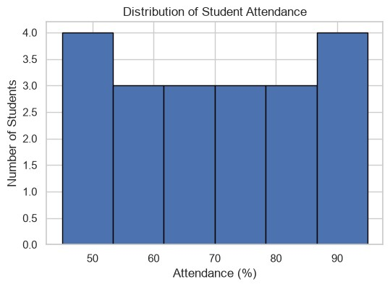
# ==========================================================
# Histogram
# ==========================================================
plt.figure(figsize=(6,4)) plt.hist(df1["Attendance"], bins=6, edgecolor="black") plt.title("Distribution of Student Attendance") plt.xlabel("Attendance (%)") plt.ylabel("Number of Students") plt.show()
In [13]:

# ==========================================================
# Bar Chart
# ========================================================== plt.figure(figsize=(6,4)) df1["Result"].value_counts().plot(kind="bar")
plt.title("Pass vs Fail Students") plt.xlabel("Result")
plt.ylabel("Number of Students") plt.show()
In [14]:
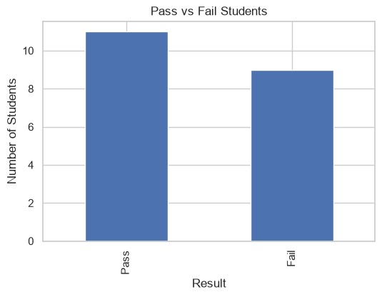
# ==========================================================
# Scatter Plot
# ========================================================== plt.figure(figsize=(6,4)) plt.scatter(df1["Study_Hours"], df1["Internal_Marks"])
plt.title("Study Hours vs Internal Marks") plt.xlabel("Study Hours") plt.ylabel("Internal Marks") plt.show()
In [15]:
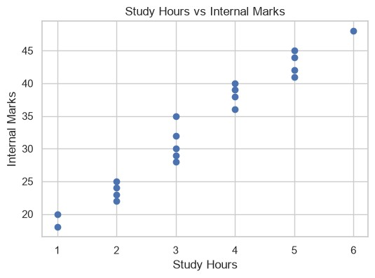
# ==========================================================
# Box Plot
# ========================================================== plt.figure(figsize=(6,4)) plt.boxplot(df1["Attendance"]) plt.title("Attendance Box Plot") plt.ylabel("Attendance") plt.show()
In [16]:
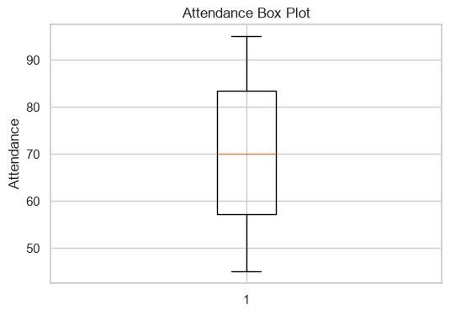
# ==========================================================
# Pie Chart
# ========================================================== plt.figure(figsize=(5,5))
df1["Result"].value_counts().plot( kind="pie", autopct="%1.1f%%"
)
plt.title("Pass and Fail Percentage") plt.ylabel("") plt.show()
In [17]:
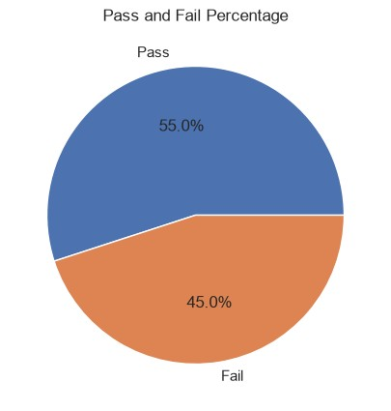
# ==========================================================
# Heatmap
# ========================================================== plt.figure(figsize=(6,4))
sns.heatmap( df1.select_dtypes(include=np.number).corr(), annot=True, cmap="coolwarm"
) plt.title("Correlation Heatmap") plt.show()
In [18]:
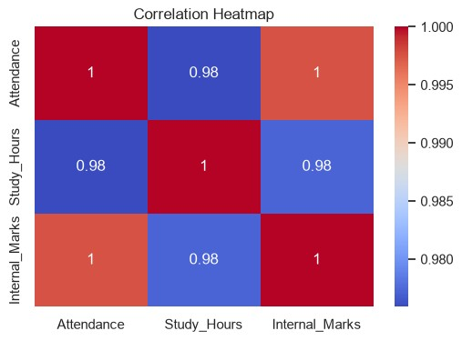
Observations
- Students with higher attendance generally achieved better internal marks and final results.
- Students studying more hours tended to score higher marks.
- The majority of students with internal marks above 35 passed the examination
- Attendance and study hours show a positive relationship with academic performance.</p>
- No missing values or duplicate records were found, indicating good data quality.
- The Exploratory Data Analysis (EDA) shows that attendance, study hours, and internal marks have a significant impact on student performance. Students who attend classes regularly and study consistently tend to score higher internal marks and are more likely to pass the examination. The analysis also highlights the importance of understanding data before building predictive models or making academic decisions. Overall, EDA helps educational institutions identify the key factors affecting student success and supports better planning and decision-making to improve academic outcomes.

